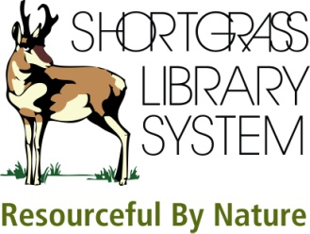 | TumbleBooks – eBooks for Kids  Electronic Resource

1. (a) Describe how you play a TumbleBook. (b) What happens when you add it to a playlist?

2. TumbleBooks offers stories in different languages. What languages are available?

3. (a) How many books are available on TumbleBooks from popular author (and actor) John Lithgow? (b) How many of these books are narrated by John Lithgow?

4. (a) How many puzzles/games are available for Robert Munsch’s book, The Paper Bag Princess? (b) What are the different categories (types of games) for the puzzles and games section?

5. Please provide the Reading Level (Grade, Lexile, and Accelerated Reader) for the
non-fiction title, The Bumblebee Queen.

