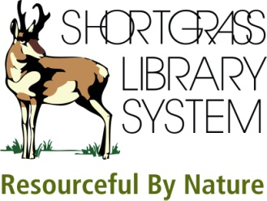 | NoveList  Electronic Resource

1. Name one of the authors recommended in the Author Read-alike for Spider Robinson?

2. List one of the questions in the Book Discussion Guide for The Maltese Falcon.

3. (a) I just finished reading Hogfather (I think it’s by Terry Pratchett). (b) Is it part of a series? (c) If so, what is the series called and where is this book in the series (is it the first book, or tenth or forty-fourth)?

4. I really enjoyed the Millennium trilogy by Stieg Larsson (The Girl with the Dragon Tattoo, The Girl Who Played with Fire, and The Girl Who Kicked the Hornet's Nest). I know that there are no other books currently available in this series. (a) What are some other books along the lines of the Millennium trilogy that you could recommend? (b) How did you go about answering this question?

5. (a) What is the title of the first book recommended for Ages 9 -12, under Sports Stories – Hockey? (Tip: use the Recommended Reads Lists section on the left hand side of the screen.) (b) Is this book in the collection of the Shortgrass public libraries?

