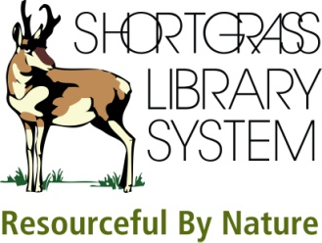 | Mango Languages  Electronic Resource

1. Mango Languages offers several courses in Foreign Languages for English Speakers. Which ones are considered 'popular courses?'

2. Mango Languages also offers English courses for English as a Second Language learners. How many different languages are the English courses available in?

3. (a) What is the difference between Mango Basic and Mango Complete 2.0? (b) Is Mango Complete 2.0 available for all Mango Language courses? (c) How many chapters make up the French Mango Basic course? (d) How many chapters make up the French Mango Complete 2.0 course?

4. (a) In the Italian Mango Complete 2.0 course, what is chapter 9? (b) In Chapter 9, Lesson 36, you are taught the word 'legge.' What does it mean?

5. (a) What are the minimum requirements for your computer to run Mango Languages? (b) Do you need speakers or a microphone to complete lessons?

