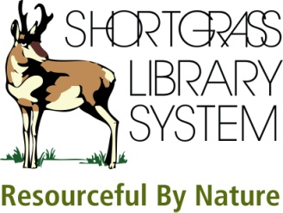 | Ancestry Library Edition  Electronic Resource

1. You are looking for information about John Jennings, born in Roscommon Ireland. His wife’s name was Bridget but you’re not sure of the spelling.
a. What was his estimated birth year?
b. What was his father’s name?
c. How is the wife’s name spelled?

2. You are searching for information about Alice Dunne who emigrated from Londonderry to New York sometime between 1910 and 1913. Hint: You can use the +/- years feature next to the year of arrival on the search form.
a. What was her date of arrival in New York?
b. What was the name of the ship?
c. Can you view an image of the ship?

3. According to family lore, you have an ancestor – last name Longhurst – who was sent as a convict to Australia. He may have been born in Sussex. Search the Australian Convict Index to find out:
a. His first name
b. His occupation

4. Author Viktor Frankl (born 1905) wrote Man’s Search for Meaning about his Holocaust experience in four different concentration/labour camps. Records included in Ancestry Library Edition name two of those camps. What were they?

